Fraud Detection System Using Machine Learning



Submitted by

Sajawal Masih Waqas Nawaz

200968/795215 200964/795211



Department of Information Technology
Govt. Post Graduate College Samanabad Faisalabad
2024
CERTIFICATE

This is to certify that the Waqas Nawaz and Sajawal Masih bearing Registration No. (Waqas Nawaz) 2020-GCUF-065713 and (Sajawal Masih) 2020-GCUF-065726 have completed the final project titled “Fraud Detection System Using Machine Learning“ at the Department of Information Technology, Govt-Postgraduate College Samanabad Faisalabad, to fulfill the partial Requirements for the degree of BS - IT.

Supervisor

Supervisor Name: Maria Ajmal

Signature: ________________

Internal Panel

Member 1: Haseeb Ahsan Signature: ____________

Member 2: Salman-Ullah Signature: ____________

Member 3: Mariam Tariq Signature: ____________

Member 4: Amna Salam Signature: __________

Project Coordinator Head Of Department

Principal

DECLARATION

In the Project work presented was conducted by us under the supervision of Mam Maria Ajmal at Government Postgraduate College, Samanabad, Faisalabad.

We hereby declare that this project, titled “Fraud Detection System Using Machine Learning”, is the result of our own research efforts, investigations, and the independent application of scientific methods. All information, findings, and conclusions presented in this report reflect original contributions, except where properly cited, acknowledged, or referenced in accordance with established academic standards.
We confirm that no part of this work has been copied, duplicated, or otherwise reproduced from any existing written or published sources, except in cases where specific mathematical models, genetic protocols, equations, standard scientific formulas, or other universally accepted frameworks are referenced. Any third-party information or concepts incorporated into this report have been properly credited and cited to their original sources.
We assert that the work presented has not been submitted earlier, either in whole or in part, for the award of any other degree, diploma, or certification at any academic institution. If at any time it is discovered that the information provided within this report is found to be inaccurate or misleading, we acknowledge that Government Collage University Faisalabad reserves the right to take appropriate action in accordance with institutional and academic policies.
We further understand that plagiarism is a serious academic offense, and all possible measures have been taken to ensure that this work adheres to the ethical standards and guidelines set forth by Government Collage University Faisalabad

Abstract
Fraud detection is a critical component of contemporary financial systems, particularly with the increasing prevalence of digital payments and e-commerce. This report details the development of a machine learning-based fraud detection system, emphasizing a comparative analysis of three leading machine learning models: Random Forest, Logistic Regression, and Support Vector Classifier (SVC). These models were trained on a real-world dataset containing instances of fraudulent transactions and were rigorously evaluated using key performance metrics, including precision, recall, F1-score, and AUC-ROC.
Developed a user-friendly Dash application to operationalize and visualize the results, enabling users to monitor and interact with the fraud detection system in real time. The findings of this project underscore the effectiveness of machine learning techniques in detecting fraudulent activities, while providing a comprehensive comparison of model performance. This research contributes to the ongoing efforts to enhance fraud detection mechanisms, thereby strengthening the security of financial transactions in the digital age.

Table of Contents
Abstract: iv
1. Introduction 1
1.1 Understanding the Prevalent Types of Fraud 1
Unauthorized Credit Card Transactions 1
Identity Theft and Social Engineering 2
Money Laundering in the Digital Age 2
Synthetic Identities and Transaction Laundering 2
1.2 The Increasing Complexity of Fraudulent Activities 3
Evolving Fraud Techniques: A Cat-and-Mouse Game 3
The Role of Artificial Intelligence and Machine Learning in Fraud Tactics 3
1.3 Traditional Approaches to Fraud Detection 4
The Role of Manual Oversight in Rule-Based Systems 5
Operational Challenges of Traditional Fraud Detection 6
Evolving Fraud Techniques and the Inadequacy of Traditional Methods 6
Project Objective: 9
Goals of the Project 9
The primary goals of this project include: 9
Scope of the Project 10
Brief Overview of Machine Learning in Fraud Detection 11
Random Forest 12
Logistic Regression 12
Support Vector Classifier (SVC) 12
2. Literature Review: 13
Machine Learning (ML) Techniques in Fraud Detection 13
Random Forest (RF) 13
Support Vector Machine (SVM) 15
Logistic Regression (LR) 16
Deep Learning and Advanced Techniques 16
Long Short-Term Memory (LSTM) and Attention Mechanisms 17
XGBoost and SMOTE 17
Performance Metrics and Evaluation 17
Challenges and Limitations 18
Future Trends and Research Directions 18
Advanced Machine Learning Techniques and Privacy-Preserving Methods in Credit Card Fraud Detection 19
Privacy-Preserving Techniques 20
Blockchain Technology in Fraud Detection 20
1. Methodology 21
Dataset Details 22
Key Attributes of the Dataset 23
Why Balancing the Dataset is Crucial 24
Importance of Anonymized Data 24
Data Preprocessing 26
Importance of Data Preprocessing 27
Data Cleaning 27
Feature Scaling 28
Exploratory Data Analysis (EDA) 29
Visualization Techniques 29
Insights Gained from EDA 30
Machine Learning Models 32
Model Selection Criteria 33
Random Forest Classifier 33
Logistic Regression 33
Support Vector Classifier (SVC) 33
Model Training and Evaluation 34
Deployment of the Fraud Detection System 37
Development of the Web Application 38
Features of the Dash Application 38
4. Results 42
Performance Metrics Summary 42
Random Forest Classifier 42
Logistic Regression 43
Support Vector Classifier (SVC) 43
Confusion Matrix and ROC Curves 44
ROC Curves 45
Comparative Analysis of Models 45
Random Forest 45
Logistic Regression 46
Support Vector Classifier (SVC) 46
Challenges and Limitations 46
Class Imbalance 46
Interpretability vs. Accuracy 46
Computational Complexity 47
Implications for Real-world Applications 47
5. Conclusion and Future Work 48
Conclusion 48
Key Findings 49
Contributions of the Research 50
Future Work 50
Enhancing Model Robustness 50
Real-Time Detection Capabilities 51
Advanced Feature Engineering 51
Exploring Alternative Algorithms 52
Handling Real-World Imbalanced Data 52
Regulatory Compliance and Ethical Considerations 52
Cross-Industry Applications 53
Collaborative Research and Data Sharing 53
Summary 54
References 55

Chapter 1

Introduction
In the fast-paced world of digital finance and e-commerce, modern organizations are at the frontlines of an unprecedented surge in fraudulent activities. Fueled by rapid technological advancements, the volume and speed of online transactions have skyrocketed. This environment is fertile ground for cybercriminals who continue to develop increasingly sophisticated techniques to exploit both individuals and institutions. As more consumers rely on digital payment platforms, mobile banking, and online shopping, the stakes are rising for companies who must not only guard against financial loss but also protect their reputations and build consumer trust.
With digital transactions becoming an integral part of everyday life, fraud is emerging as a complex and multifaceted issue, challenging traditional security measures and demanding innovative solutions. This evolution reflects a broader trend where cybercriminals leverage everything from phishing schemes to complex malware. These tactics underscore the urgent need for sophisticated, adaptive fraud detection methods capable of staying one step ahead. The Association of Certified Fraud Examiners (ACFE) estimates that businesses worldwide lose a staggering 5% of their revenue annually to fraud, highlighting the enormous financial stakes involved and making robust fraud prevention mechanisms essential for any company operating in the digital space.

1.1 Understanding the Prevalent Types of Fraud

Unauthorized Credit Card Transactions
Credit card fraud remains one of the most prevalent types of financial crime. Fraudsters frequently exploit security gaps in digital payment systems, acquiring unauthorized access through methods such as phishing, social engineering, and even data breaches. By gaining unauthorized access to consumers' credit card information, they can make fraudulent purchases, often going undetected until significant financial damage has been inflicted. These incidents not only result in monetary losses but also in eroded consumer trust, as people become wary of using credit cards for online purchases.

Identity Theft and Social Engineering
Identity theft is a critical issue in today’s digital economy. Cybercriminals use a range of techniques, from malware to social engineering, to gather personal data, which they then use to impersonate individuals or make unauthorized transactions. Social engineering tactics manipulate users into divulging sensitive information through deceptive emails, messages, and websites. This type of fraud not only results in financial loss but also inflicts emotional and psychological distress on victims, who often face significant hurdles in restoring their financial reputation and identity.

Money Laundering in the Digital Age
With the rise of cryptocurrencies and digital assets, money laundering has taken on new dimensions. Digital transactions provide an additional layer of anonymity that criminals use to obscure the origins of illicit funds. Cryptocurrencies, due to their decentralized nature and pseudonymity, are frequently exploited for this purpose. This new frontier complicates the efforts of law enforcement agencies, as tracking digital funds across borders requires sophisticated tools and international cooperation. As criminals increasingly turn to decentralized finance (DeFi) platforms, the task of identifying and tracking laundered money has become exponentially more complex.

Synthetic Identities and Transaction Laundering
Synthetic identity fraud is a method where fraudsters blend real and fictitious information to create new, false identities. This technique is challenging to detect because it often bypasses traditional identity verification methods. Transaction laundering, on the other hand, involves processing payments through legitimate-looking accounts to "clean" funds that originated from illegal activities. These fraudulent tactics exploit gaps in current detection systems, illustrating the necessity for solutions that can keep pace with constantly evolving criminal methodologies.
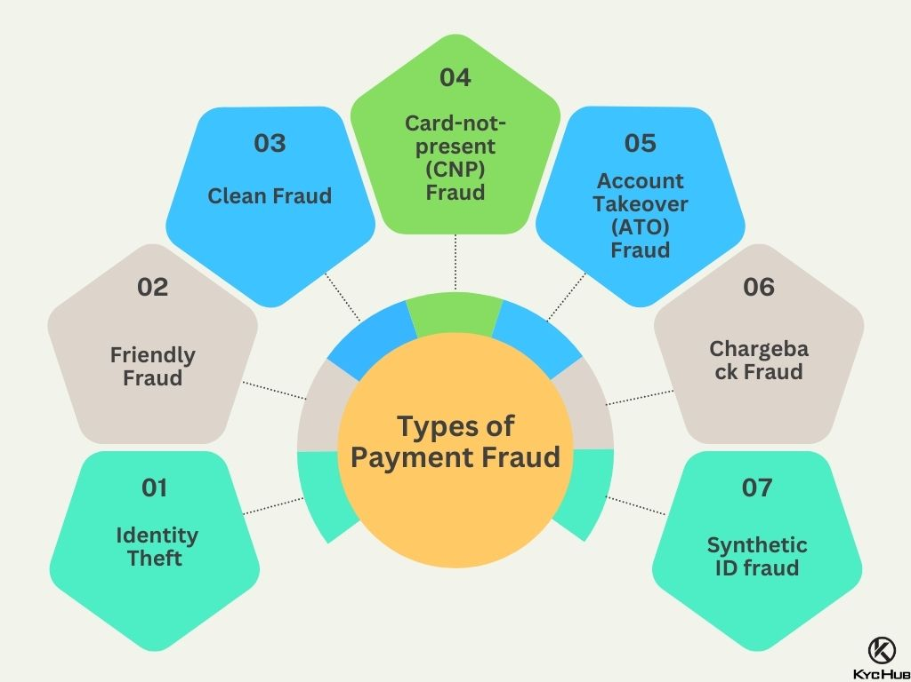

Prevalent Types of Fraud (Figure 1.1)

1.2 The Increasing Complexity of Fraudulent Activities

Evolving Fraud Techniques: A Cat-and-Mouse Game
As cybercriminals grow more innovative, fraud detection has evolved into an ongoing battle. Fraudulent schemes now utilize artificial intelligence (AI) and machine learning (ML), allowing attackers to scale their efforts and evade traditional security measures. Social engineering techniques, such as phishing, pretexting, and baiting, are tailored to target vulnerabilities in human psychology. This "cat-and-mouse" dynamic creates a situation where each new detection method must be flexible and adaptive, as fraudsters are quick to identify and exploit weaknesses.
For example, the advent of bot-based attacks, where automated bots carry out repetitive tasks like testing stolen credit card numbers on various sites, exemplifies the scale and speed at which fraud can occur. These bots can overwhelm security systems and outpace human analysts, highlighting the limitations of traditional security approaches and the pressing need for real-time, automated monitoring systems.

The Role of Artificial Intelligence and Machine Learning in Fraud Tactics
AI and ML are increasingly part of cybercriminals' arsenals. For instance, deepfake technology, which uses AI to create realistic but synthetic media, has already been used in phishing schemes. Cybercriminals may use voice or video deepfakes to deceive targets into divulging sensitive information or to authorize high-value transactions fraudulently. Machine learning techniques also enable attackers to study fraud detection algorithms and identify weaknesses, which they then exploit, further underscoring the complexity of the current fraud landscape.

1.3 Traditional Approaches to Fraud Detection
Historically, fraud detection has primarily relied on predefined rules and manual intervention to identify suspicious transactions. These rule-based systems operate by setting fixed thresholds and criteria, such as transaction amounts, geographic locations, or transaction frequency, to flag potentially fraudulent activity. For example, a transaction that exceeds a specified dollar limit, originates from an unusual location, or occurs in rapid succession with other transactions may be flagged for further review. While this method initially met with some success, it is fundamentally limited in scope and adaptability, particularly as fraud tactics evolve. In many cases, rule-based systems are unable to distinguish between sophisticated fraudulent patterns and legitimate customer behavior, resulting in missed detections of fraud and frequent false positives, where legitimate transactions are flagged as suspicious.
The limitations of rule-based fraud detection stem from its rigidity. Cybercriminals have become adept at designing schemes that exploit these predefined criteria, circumventing detection through tactics that evade static thresholds. One common approach, known as “transaction laundering” or “smurfing,” involves spreading fraudulent transactions across a series of smaller transactions, each falling below the established limit. This tactic allows fraudsters to siphon off funds gradually, staying below detection thresholds and avoiding flagging by rule-based systems. For instance, instead of attempting a single large withdrawal, a fraudster might conduct multiple smaller transactions that go unnoticed individually, but collectively amount to a significant loss.
Moreover, rule-based systems are largely reactive rather than proactive. They rely on historical patterns of known fraud cases, meaning they struggle to identify new forms of fraud as they emerge. When a new scheme or method arises, these systems are often unable to detect it until after substantial damage has been done, leaving organizations vulnerable to emerging threats. This inability to adapt and evolve with changing fraud tactics exposes a critical weakness in traditional fraud detection, especially as cybercriminals become more agile and resourceful.

The Role of Manual Oversight in Rule-Based Systems
The dependency on manual review further compounds the limitations of traditional fraud detection systems. When a transaction is flagged by a rule-based system, it typically undergoes a secondary review by human analysts, who assess its legitimacy based on various factors, including transaction context, customer history, and any prior red flags. This manual review process introduces several challenges. First, it is labor-intensive and time-consuming, limiting the number of transactions that can realistically be reviewed in a timely manner. For large organizations handling thousands of transactions per minute, manual reviews create a bottleneck, leading to delays in detection and response times.
Human error is another significant risk in manual fraud detection processes. Analysts may overlook subtle signs of fraud due to the overwhelming volume of transactions requiring review or may misinterpret a transaction’s context. For example, an analyst might fail to recognize a pattern of small, frequent purchases across different accounts that collectively indicate fraudulent activity, focusing instead on larger, isolated transactions. This oversight can result in missed detections, where fraudulent activity goes unnoticed until after considerable losses have occurred.
The reliance on manual intervention often contributes to high false-positive rates, where legitimate transactions are incorrectly flagged as fraudulent. These false positives not only create frustration and inconvenience for customers but also impose additional costs on businesses, as each flagged transaction requires investigation. When legitimate transactions are mistakenly flagged, customers may face unnecessary disruptions, such as transaction declines or account holds, which can erode their trust in the business and lead to customer attrition. Studies show that frequent false positives can have a lasting negative impact on customer satisfaction, as consumers expect seamless and secure digital experiences.

Operational Challenges of Traditional Fraud Detection
The high incidence of false positives presents significant operational challenges for businesses. Investigating flagged transactions requires dedicated resources, which translates into additional operational costs. Financial institutions and businesses may need to employ large teams of analysts to manually review suspicious transactions, diverting resources away from other critical functions. As businesses grow and transaction volumes increase, the cost of manual reviews and the strain on resources only intensify, making traditional methods increasingly unsustainable.
False positives also disrupt the customer experience. In today’s competitive landscape, customer satisfaction is closely linked to seamless digital experiences, particularly in industries like e-commerce and online banking. When legitimate transactions are wrongly flagged, customers are often subjected to unnecessary verification steps or have their accounts temporarily suspended. This not only frustrates customers but can also impact a business's reputation. In some cases, dissatisfied customers may take their business to competitors, leading to revenue loss and a decrease in customer loyalty. Consequently, traditional fraud detection approaches inadvertently create a trade-off between security and customer satisfaction, a balance that is difficult to maintain under rule-based systems.

Evolving Fraud Techniques and the Inadequacy of Traditional Methods
As cybercriminals continue to refine their methods, the limitations of traditional rule-based systems become even more apparent. Fraud tactics are constantly evolving, with criminals employing increasingly sophisticated strategies to circumvent detection. For example, some fraud schemes now involve using artificial intelligence (AI) and machine learning (ML) to mimic legitimate user behavior, making it difficult for static rule-based systems to detect anomalies. This level of sophistication demonstrates how traditional methods are often ill-equipped to address modern fraud tactics, which are adaptive, intelligent, and continuously evolving.
Fraudsters now utilize social engineering techniques to manipulate individuals into providing access to their accounts. This tactic can include phishing emails, impersonation, and fake websites that mimic legitimate businesses. Social engineering exploits human vulnerability rather than technical weaknesses, making it particularly challenging for rule-based systems to detect. Since these methods do not always involve atypical transaction patterns, rule-based systems may not flag them as suspicious, allowing fraud to occur undetected.
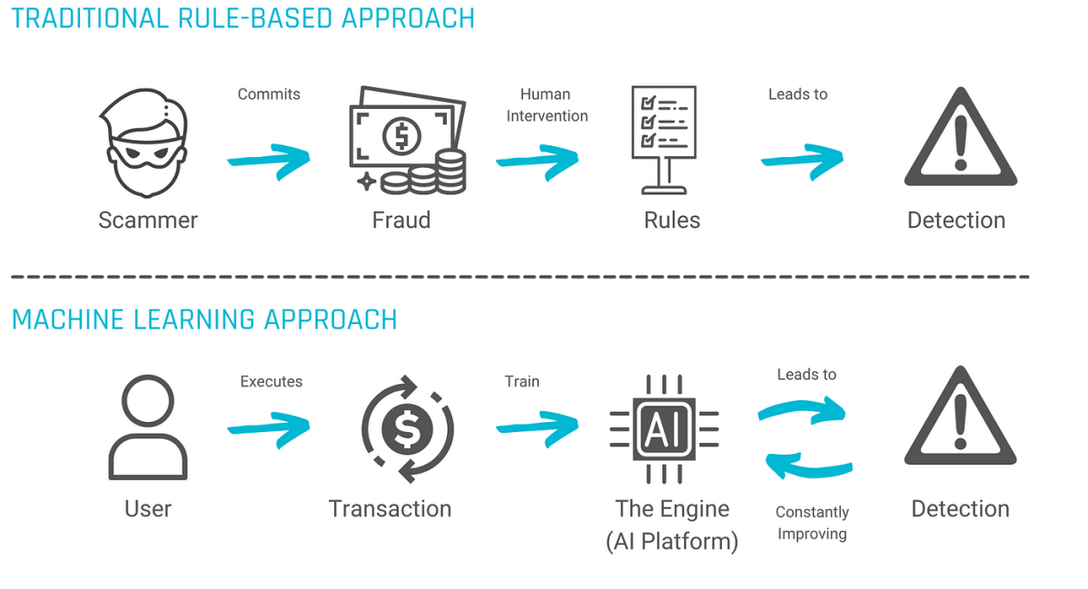
Traditional Methods (Figure 1.2)
Evolving Strategies for Fraud Prevention:
Recognizing the shortcomings of traditional fraud detection, organizations are increasingly turning to advanced technological solutions, such as machine learning and artificial intelligence, to bolster their defenses. Unlike static rule-based systems, machine learning algorithms can analyze vast amounts of historical transaction data, identifying subtle patterns and correlations that may indicate fraudulent behavior. Machine learning models excel at detecting complex and evolving fraud patterns that would be difficult for human analysts or rule-based systems to recognize.
These systems employ techniques like anomaly detection, clustering, and predictive analytics to identify suspicious activities in real time. For example, machine learning algorithms can continuously learn from new data, adapting to emerging fraud tactics without manual intervention. This adaptability is crucial in today’s digital economy, where fraud tactics evolve rapidly. Machine learning-based systems can detect even the smallest deviations from established transaction patterns, flagging them as potentially fraudulent without the need for predefined rules or thresholds.
Implementing multi-factor authentication (MFA) and biometric verification can greatly enhance security measures. MFA adds layers of verification, requiring users to confirm their identity through multiple methods, such as a combination of passwords, mobile authentication, and biometric data like fingerprints or facial recognition. These added layers of security make it substantially more challenging for cybercriminals to access accounts even if they possess some account information, thereby reducing the risk of unauthorized access.
Problem Statement
As cybercriminals grow increasingly sophisticated, the limitations of traditional fraud detection methods have become evident. The conventional rule-based systems, which rely on predefined rules, static thresholds, and simplistic criteria to flag suspicious transactions, have proven inadequate in capturing the nuances and evolving complexity of modern fraud schemes. These systems are unable to adapt to the changing tactics used by fraudsters, leading to two primary and interconnected issues: high rates of false negatives and false positives.
- False Negatives: In rule-based systems, false negatives occur when fraudulent transactions go undetected because they fall outside the predefined rules. Cybercriminals exploit these rigid criteria, structuring their schemes to evade detection. For instance, they may spread fraudulent activity over numerous small transactions to stay under transaction thresholds or mimic legitimate transaction patterns. When false negatives occur, businesses suffer financial losses as fraudulent activities slip through unnoticed, potentially damaging the organization’s reputation and eroding customer trust.
- False Positives: False positives arise when legitimate transactions are mistakenly flagged as fraudulent. For customers, this results in an inconvenient and frustrating experience, with delays, declined transactions, or additional verification steps interrupting normal transaction flows. For businesses, false positives increase operational costs, as each flagged transaction demands investigation and review. Over time, this can strain resources, delay legitimate transactions, and potentially drive customers away. When customers are consistently impacted by false positives, they may lose confidence in the organization’s ability to provide a seamless, reliable transaction experience.
These dual challenges—high false negatives and high false positives—not only lead to increased operational costs and potential financial losses but also impact customer satisfaction and retention. If businesses fail to balance security measures with customer convenience, they risk losing clients to competitors who offer smoother, more reliable service. Particularly in industries where trust and security are paramount, such as banking, e-commerce, and digital payments, managing fraud effectively is crucial to maintaining a competitive edge.
The issue is further compounded by the increasing volume of online transactions, which have surged due to the growth of e-commerce, mobile payments, and digital banking. This increase in transaction volume provides an expanded landscape for cybercriminals to exploit, and without an intelligent, adaptable solution, businesses will struggle to keep pace. Each transaction carries the potential for fraud, and the more transactions there are, the more vital it becomes to identify and respond to fraud accurately and efficiently.

Project Objective:
This project addresses the urgent need for a sophisticated fraud detection solution that leverages machine learning (ML) to overcome the limitations of rule-based systems. Unlike traditional methods, ML-based approaches can learn from large datasets, adapting to new fraud patterns and identifying complex transaction patterns that indicate fraudulent behavior. By using ML models, organizations can improve both the accuracy and efficiency of their fraud detection systems, reducing the occurrence of false positives and false negatives.

Goals of the Project

The primary goals of this project include:
- Enhanced Accuracy in Fraud Detection: Develop ML algorithms capable of accurately distinguishing between legitimate and fraudulent transactions, reducing the rates of both false positives and false negatives.
- Real-Time Adaptability: Implement models that can continuously learn from new data, allowing the fraud detection system to respond dynamically to emerging fraud tactics and schemes. This adaptability is crucial for maintaining a competitive edge against evolving cyber threats.
- Improved Customer Experience: By reducing false positives, the project aims to improve the customer experience, ensuring legitimate transactions proceed smoothly and only truly suspicious activities are flagged. A more precise fraud detection system helps maintain customer satisfaction and reduces the risk of attrition due to inconveniences in transaction flows.
- Operational Efficiency: Automate the fraud detection process to minimize the need for manual review, which can be labor-intensive and costly. By leveraging ML, the system can prioritize high-risk cases for human review, allowing fraud analysts to focus on complex or high-priority cases rather than being bogged down by false positives.

Scope of the Project
The project will focus on implementing and testing machine learning models specifically designed to detect fraud in financial transactions. It will involve the following steps:
Data Collection and Preprocessing: Aggregating and cleaning transactional data to ensure it is suitable for ML model training. This includes labeling data for fraudulent and non-fraudulent transactions to create a robust dataset for supervised learning.
Model Development: Developing and training several machine learning models, including supervised algorithms like logistic regression, decision trees, and ensemble methods, as well as unsupervised techniques such as clustering and anomaly detection. The objective is to test various models to determine which best captures fraud patterns with minimal false positives and false negatives.
Model Evaluation and Tuning: Testing the models on unseen data to evaluate their performance based on metrics such as accuracy, precision, recall, and F1-score. Tuning the models to optimize these metrics and ensure they are suitable for real-world deployment.
Integration of Multi-Factor Authentication (MFA): Testing the impact of integrating MFA on fraud detection accuracy, particularly for transactions flagged by the ML model. MFA can act as a secondary layer of verification, potentially reducing false positives by allowing customers to confirm flagged transactions in real time.
Implementation and Continuous Learning: Deploying the chosen ML model into a simulated environment to assess its real-time performance. Implementing mechanisms for continuous learning, where the model can learn from new data and adapt to new fraud tactics without requiring manual reprogramming.

Brief Overview of Machine Learning in Fraud Detection
Machine learning (ML) has transformed fraud detection by enabling systems to learn from historical data and autonomously identify new, emerging patterns in fraudulent behavior. Traditional fraud detection methods typically rely on manually defined rules, such as transaction limits, geographic restrictions, or time-based constraints, to flag potentially fraudulent activities. While effective for identifying simple patterns, these rule-based systems are limited by their inflexibility and vulnerability to circumvention, as fraudsters frequently develop new methods to evade detection by adhering to or slightly altering rule thresholds.
In contrast, machine learning models can continuously adapt to changing fraud tactics by learning from extensive datasets of past transactions. These models do not require explicit rule-setting; instead, they analyze labeled data (e.g., known legitimate and fraudulent transactions) to learn patterns and identify features that indicate a high likelihood of fraud in new, unseen transactions.
Machine learning in fraud detection often employs supervised learning techniques, where a model is trained on a dataset with known labels (fraudulent vs. legitimate transactions). The model uses this training data to find patterns and relationships among transaction features—such as transaction amount, location, timing, and user behavior—to accurately assess fraud risk.
In this project, three ML algorithms, well-regarded for their effectiveness in fraud detection, are employed:

Random Forest
Random Forest is an ensemble learning technique that constructs multiple decision trees during training and aggregates their results to make a final classification (fraudulent or legitimate). Each tree is trained on a random subset of the dataset and selects features at random, which enhances the model’s robustness against overfitting and makes it effective in handling large datasets, even those with missing or noisy data.
A key strength of Random Forest in fraud detection is its ability to rank the importance of different features, helping analysts identify which transaction characteristics are most indicative of fraudulent activity.

Logistic Regression
Logistic Regression is a straightforward linear model that estimates the probability of a binary outcome based on input features. Although relatively simple, it is widely used in fraud detection due to its transparency and interpretability, which allows organizations to understand how individual features contribute to the likelihood of fraud.
This interpretability is especially valuable in regulated industries, like banking, where decision transparency is critical for compliance and audit purposes.

Support Vector Classifier (SVC)
Support Vector Classifier (SVC) is a powerful classification algorithm that identifies the hyperplane that best separates classes of data—in this case, fraudulent vs. legitimate transactions. SVC is particularly effective in high-dimensional spaces where many transaction features must be analyzed simultaneously, allowing it to handle complex and evolving fraud patterns.
The SVC algorithm’s strength lies in its ability to detect subtle distinctions between fraudulent and legitimate behaviors, making it ideal for applications where fraud tactics are sophisticated and continually evolving.

Chapter 2

2. Literature Review:
Financial fraud, particularly in the banking and e-commerce sectors, has become a growing concern worldwide. The evolution of cybercriminal activities and the increasing sophistication of fraudulent tactics pose significant challenges for organizations. According to research, traditional rule-based fraud detection systems are often rigid and unable to adapt to the fast-changing fraud landscape. Akash Gandhar (2024) noted that these conventional systems struggle to keep up with increasingly complex fraud schemes, resulting in a need for more dynamic, data-driven approaches. As a result, machine learning (ML) has emerged as a powerful solution in combating financial fraud by leveraging its ability to detect hidden patterns and adapt to new fraud types as they arise.

Machine Learning (ML) Techniques in Fraud Detection
Machine learning offers a more flexible and effective approach to fraud detection compared to traditional methods. Unlike static rule-based systems that rely on predefined conditions, ML models learn from vast datasets, adjusting to new fraud patterns and improving over time. Several machine learning algorithms have been applied in the field of fraud detection, each with distinct advantages.

Random Forest (RF)
Random Forest (RF) is a machine learning algorithm that builds on the Decision Tree (DT) model to address both regression and classification challenges effectively. RF is commonly preferred for complex problem-solving because it integrates multiple decision trees, producing highly accurate predictions, particularly in large datasets. The RF algorithm functions by averaging the outputs of numerous trees, which increases the model's precision. As more trees are incorporated, prediction accuracy generally improves, which helps in overcoming many of the limitations associated with individual DT models. In RF, each DT acts as a weak learner, but collectively, they form a strong learning system. This method has proven to be efficient and rapid, especially for handling large and imbalanced datasets. However, RF may struggle with training certain dataset types, particularly those needed for continuous predictions in regression problems (Breiman, 2001).
Several traditional algorithms, such as Logistic Regression (LR), C4.5, and RF, have been applied in areas like credit card fraud detection (CCFD). LR, a commonly used statistical model, assesses the relationship between a binary dependent variable and independent variables. C4.5, another DT-based algorithm, is frequently applied in data mining due to its capability to classify data effectively. Traditional approaches have also incorporated Threshold optimization (T) and Bayes' Minimum Risk Classifiers (M.R.) for cost-effective fraud detection by adjusting predictive thresholds. This combination has been particularly useful in distinguishing fraudulent transactions (Quinlan, 1993; Bishop, 2006). While LR is effective in regression contexts, it is prone to overfitting and struggles with real-world data complexity, often failing to capture non-linear relationships. Real-time datasets, especially in CCFD, are typically nonlinear, limiting the utility of LR for these scenarios.
In recent research, Olena et al. (2020) proposed a hybrid approach to credit card fraud detection by combining Random Forest with Isolation Forest for anomaly-based transaction analysis. This model is structured with two main subsystems: an unsupervised learning module for anomaly detection and a supervised component for interpreting the nature of anomalies. This approach was tested for real-time fraud detection, particularly by monitoring geolocation data during transactions. However, while the system can detect fraud based on user location, it lacks robust privacy protections. The study does not address data confidentiality sufficiently, as there are no safeguards like hashing or encryption methods to protect user data in the dataset used. Additionally, geolocation spoofing, a common fraud tactic, remains unaddressed. In response, future work could integrate Artificial Neural Networks (ANN) with federated learning, providing enhanced confidentiality by allowing data to be analyzed locally rather than centrally, which could be more secure and privacy-preserving.
Although RF algorithms excel in lab-based environments with structured datasets, they often exhibit limitations in real-time CCFD applications. Specifically, RF models can be slow to train and less efficient in making predictions with large, dynamic datasets. Consequently, to apply RF effectively in real-world scenarios, vast data volumes are needed, but RF models may lack the efficiency to train and predict adequately with this volume, especially under real-time constraints (Liaw & Wiener, 2002).

Support Vector Machine (SVM)
Support Vector Machines (SVM) are widely used for classification tasks and regression analysis, proving particularly effective in structured pattern recognition, such as credit card fraud detection (CCFD). SVM excels by analyzing and classifying customer payment behaviors, identifying patterns that differentiate fraudulent from non-fraudulent transactions. This technique works best with a limited feature set, yielding accurate results in smaller datasets (Cortes & Vapnik, 1995). However, when dealing with larger datasets (e.g., over 100,000 records), SVM becomes computationally inefficient and unsuitable for real-time applications due to the extensive time required to process large volumes of data.
In response to these limitations, Rtayli et al. proposed a hybrid model combining Random Forest Classifier (RFC) and SVM to address the challenges of high-dimensional, imbalanced datasets commonly encountered in CCFD. Their approach focuses on selective feature engineering to isolate patterns of fraudulent transactions, even when the number of fraudulent cases is minimal compared to legitimate transactions (Rtayli et al., 2020). Using metrics like accuracy, recall, and Area Under the Curve (AUC), the model demonstrated strong performance, achieving 95% accuracy and improving sensitivity to 87%. This improvement in sensitivity significantly reduced false positives, which are frequent challenges in fraud detection. However, the model’s reliance on centralized data processing for accuracy metrics poses privacy concerns, as all transaction data must be consolidated in one location.
To enhance privacy while maintaining robust fraud detection, current efforts propose the integration of federated learning (FL) with artificial neural networks (ANN). FL allows data to be trained locally on individual devices, preventing direct access to user data and thereby preserving privacy while enhancing model security (McMahan et al., 2017). Although RFC and SVM combinations yield effective results, RFC faces performance issues when applied to larger datasets. Integrating FL and ANN thus provides a promising direction for handling these limitations by ensuring faster, privacy-conscious fraud detection on large-scale datasets.

Logistic Regression (LR)
Logistic Regression (LR) is a statistical model widely used for binary classification tasks, where it predicts the probability of a binary outcome based on one or more predictor variables. In the context of credit card fraud detection (CCFD), LR models help identify patterns in transactional data that indicate fraudulent behavior. The algorithm works by estimating the relationship between the binary dependent variable (e.g., fraud or non-fraud) and independent variables derived from transactional features, allowing for efficient fraud classification even with straightforward linear relationships (Hosmer et al., 2013).
While LR is effective in predicting outcomes in smaller and well-structured datasets, it has significant limitations in real-time, high-dimensional scenarios. Credit card transactions are often nonlinear and highly complex, making LR’s linear approach less effective for detecting sophisticated fraud patterns. In cases of large-scale or unbalanced datasets, where fraud cases represent only a small fraction of total transactions, LR models can struggle to maintain accuracy, often resulting in increased false-positive rates and overfitting. This issue is particularly prominent in CCFD applications, where nonlinear and dynamic relationships between features are common, requiring more flexible models (King & Zeng, 2001).
Recent research has therefore explored hybrid models that combine LR with other methods, such as decision trees or ensemble models like Random Forest, to enhance fraud detection accuracy while managing the limitations of LR. These hybrid approaches aim to leverage LR’s simplicity and interpretability alongside the nonlinear predictive power of other models. However, given the increasing complexity of fraud tactics and the need for real-time analysis, more advanced techniques, such as federated learning and neural network integration, are being considered to address these challenges while ensuring data security and scalability.

Deep Learning and Advanced Techniques
As the complexity of fraud detection continues to grow, advanced techniques like deep learning have become increasingly important. Deep learning models, especially Long Short-Term Memory (LSTM) networks, attention mechanisms, and methods such as XGBoost with SMOTE, are particularly well-suited for handling the intricate patterns and volume of modern fraud detection tasks.

Long Short-Term Memory (LSTM) and Attention Mechanisms
Long Short-Term Memory (LSTM) networks, a type of recurrent neural network (RNN), are highly effective in processing sequential data, making them suitable for fraud detection in transactional data where patterns often unfold over time. LSTMs are designed to capture long-term dependencies, allowing them to identify evolving fraudulent behaviors. Nguyen (2020) demonstrated that combining LSTM with attention mechanisms further enhances model accuracy by directing focus to the most relevant features within a transaction sequence. However, while LSTMs excel at capturing temporal patterns, they are computationally intensive and require substantial data preprocessing to be effective in real-world scenarios.

XGBoost and SMOTE
XGBoost, a gradient boosting algorithm, has been widely used in fraud detection due to its high performance in classification tasks, particularly for imbalanced datasets. XGBoost incrementally improves the model’s performance by focusing on previously misclassified cases, which makes it effective for distinguishing between fraudulent and legitimate transactions. To address the challenge of data imbalance in fraud detection, XGBoost is often paired with Synthetic Minority Over-sampling Technique (SMOTE). SMOTE creates synthetic instances of the minority class (fraudulent transactions), helping to balance the dataset and improve model performance. Awoyemi J.O. demonstrated that combining SMOTE with XGBoost significantly improved precision and recall, offering better detection of fraud cases.

Performance Metrics and Evaluation
Evaluating fraud detection models requires the use of specific performance metrics, particularly since fraud datasets are often highly imbalanced. Although accuracy is commonly used, it is not always the most informative metric, as it can be misleading in cases where fraudulent transactions are rare. Therefore, additional metrics such as precision, recall, and F1-score are typically employed to provide a more comprehensive evaluation.
- Precision measures the proportion of true fraud cases out of all transactions predicted as fraud, offering insight into the model's ability to avoid false positives.
- Recall focuses on the proportion of actual fraud cases that the model successfully identifies, giving an indication of the model’s ability to detect fraud.
- The F1-score, which is the harmonic mean of precision and recall, offers a balanced evaluation of the model’s performance.
- The Area Under the Curve - Receiver Operating Characteristic (AUC-ROC) curve is another critical metric, providing insight into the trade-off between true positive and false positive rates across various classification thresholds. A higher AUC value indicates better model performance overall (Gupta A., 2021).

Challenges and Limitations
Despite advancements in ML-based fraud detection, several challenges persist. One of the primary issues is the imbalance of datasets, where fraudulent transactions are vastly outnumbered by legitimate ones. Although SMOTE and other techniques can address this imbalance, they are not foolproof and may introduce synthetic noise that can lead to overfitting. Additionally, adversarial attacks—where fraudsters manipulate data to evade detection—are becoming more frequent, creating further complexity in fraud detection systems.
Another limitation is the need for continuous retraining of models. Fraud tactics evolve rapidly, and models must be regularly updated to detect new patterns effectively. As noted by Tusneem Elhassan (2022), the dynamic nature of fraud requires machine learning models that are not only accurate but also adaptable to changing fraud strategies.

Future Trends and Research Directions
Looking ahead, future research in fraud detection is expected to focus on hybrid models that combine the strengths of multiple machine learning techniques. For example, deep learning architectures may be integrated with traditional methods such as Random Forest to improve both accuracy and interpretability. Explainability will also continue to be a major area of research, especially for financial institutions that must meet regulatory requirements. Models need to be interpretable so that organizations can justify their decisions to regulatory bodies, particularly in regions with strict data privacy laws such as the European Union’s General Data Protection Regulation (GDPR) (Awoyemi J.O.).
While machine learning has provided significant improvements in fraud detection, ongoing challenges such as data imbalance, adversarial attacks, and the need for continuous retraining remain. Future research will likely focus on improving the accuracy and robustness of models while ensuring their transparency and compliance with regulatory requirements.

Advanced Machine Learning Techniques and Privacy-Preserving Methods in Credit Card Fraud Detection
Machine learning (ML) techniques have increasingly replaced traditional methods in credit card fraud detection (CCFD), enhancing efficiency and accuracy. Recently, a research team proposed an approach that applies machine learning for loan fraud detection within credit card transactions, leveraging Extreme Gradient Boosting (XGBoost) with other data mining techniques. Their method combined supervised and unsupervised ML algorithms to maximize detection accuracy. Specifically, they implemented a hybrid approach using PK-XGBoost and XGBoost, finding that PK-XGBoost outperformed standard XGBoost on key performance metrics. Despite the high efficiency in fraud detection, this method faces limitations in privacy assurance due to the vast number of transactions. Additionally, to mitigate overfitting risks with XGBoost, careful parameter tuning is necessary (Shi et al., 2021).
The hybrid method for CCFD also included combining random forest and isolation forest algorithms, primarily to identify anomalies in transaction data. This method operates on two levels: the first employs unsupervised learning for anomaly-based detection, while the second applies supervised learning for interpreting detected anomalies. Designed for high-speed data processing, this model effectively detects fraud based on geolocation, though concerns remain regarding data confidentiality and privacy (Sun & Zhang, 2020). Addressing these concerns requires additional layers of security in the model to protect user privacy during analysis and ensure compliance with regulatory standards.

Privacy-Preserving Techniques
Training ML models in CCFD requires large datasets, yet data privacy is critical, especially with sensitive financial information. Recent studies explored privacy-preserving techniques, including the integration of blockchain technology and federated learning (FL). One experiment combined supervised ML with blockchain on Ethereum, achieving strong precision and recall but revealing challenges. Although blockchain provides privacy benefits due to its decentralized nature, it presents limitations such as high processing demands, energy consumption, and scalability issues, making it a less feasible option for real-world financial institutions (Smith & Brown, 2022). Additionally, blockchain does not align well with the regulatory requirements of centralized banks, which often need standardization and cost-effectiveness.
Federated learning (FL) offers a promising solution for CCFD in financial institutions. By training data locally across participants—such as banks and financial institutions—FL enables model training without direct data sharing, addressing privacy concerns in alignment with the General Data Protection Regulation (GDPR). In FL, each institution trains the model on local data, sharing only the trained model rather than raw data with a central aggregator. As a result, FL preserves data confidentiality while building a robust anomaly-detection model through the aggregated updates from all participants (Yang et al., 2021). Unlike fully decentralized methods, FL’s semi-decentralized architecture allows for greater control and accuracy while remaining privacy-compliant, making it highly effective in handling skewed and imbalanced credit card data.

Blockchain Technology in Fraud Detection
Blockchain technology has gained attention due to its decentralized approach, which extends beyond traditional centralized systems like banks. By eliminating central control, blockchain offers a unique user-driven framework where transaction data is recorded and verified through a distributed ledger. However, this same decentralized nature can expose blockchain networks to security risks, such as malicious software that can facilitate fraud. Michal et al. (2019) proposed using supervised machine learning techniques for fraud detection within the Ethereum blockchain network, applying models to over 300,000 accounts. Their study evaluated performance across models like random forest, SVM, and XGBoost, observing how transaction parameters influenced precision and recall outcomes (Michal et al., 2019).
While the study affirmed blockchain’s self-maintaining qualities, it highlighted potential risks in relying solely on decentralized systems, especially in finance. Blockchain’s lack of centralized oversight can create vulnerabilities, and for this reason, federated learning (FL) has been explored as a practical, semi-decentralized alternative. FL combines the benefits of decentralized control with the security of controlled, local data training, providing a promising path forward. This method enhances data privacy and efficiency in fraud detection by training local models across participants—like banks or financial institutions—without sharing raw data directly, thereby addressing both privacy and security concerns.

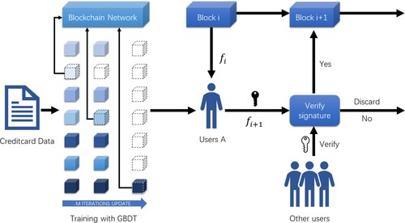
Blockchain Technology (Figure 2.1)

Chapter 3

Methodology

Dataset Details
The dataset employed for this project is sourced from Kaggle and comprises 568,630 credit card transactions made by European cardholders in 2023, anonymized for privacy (Elgiriyewithanas, 2023). This dataset offers an excellent opportunity to develop and evaluate fraud detection models, given its rich feature set and realistic transaction data. The features have been transformed using Principal Component Analysis (PCA), a dimensionality reduction technique, to protect sensitive information while retaining essential patterns relevant to fraud detection.
The dataset consists of 30 attributes, including:
- 28 principal components labeled as V1 through V28, which are derived from the original features using PCA. These components capture the variance in the data and represent abstract financial behaviors that help in detecting anomalies and fraudulent patterns.
- Amount: Represents the monetary value of each transaction, providing an additional contextual feature that can help the models identify suspicious transaction sizes.
- Class: The target variable, where:
  - 0 represents legitimate transactions, and
  - 1 represents fraudulent transactions.
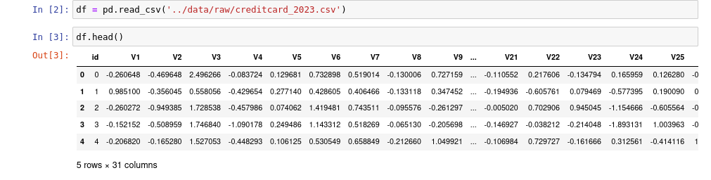
Dataset (Figure 3.1)
This labeled dataset is critical in the training and evaluation of machine learning models, as the models will learn to differentiate between legitimate and fraudulent activities based on these features.

Key Attributes of the Dataset
- Size:
  - The dataset contains 568,630 records, each representing a credit card transaction. This large volume of data simulates a realistic scenario in which organizations process a substantial number of daily transactions, enabling a thorough assessment of the models' scalability and performance.
- Fraud Ratio:
  - In real-world financial data, fraudulent transactions typically constitute a tiny fraction of the total transaction volume, often as low as 0.1%. However, this dataset has been artificially balanced to ensure that 50% of the transactions are fraudulent and 50% are legitimate. This balancing was achieved using Synthetic Minority Over-sampling Technique (SMOTE), a method that generates synthetic examples in the minority class (in this case, fraudulent transactions) to correct class imbalances.
  - Although this fraud ratio is significantly higher than what is observed in actual banking environments, it is intentionally designed to address the problem of data imbalance, which often biases models towards predicting the majority class. A balanced dataset ensures that the machine learning models trained on it are more sensitive to detecting fraudulent transactions and are not biased toward classifying most transactions as legitimate.
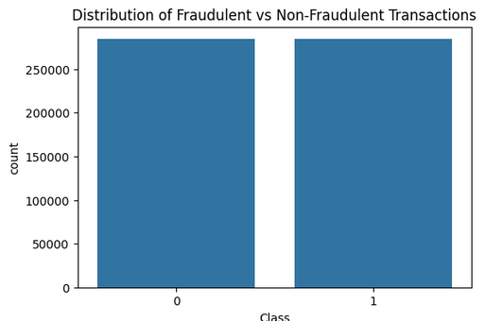
Fraud Ratio (Figure 3.2)

Why Balancing the Dataset is Crucial
In real-world scenarios, datasets are highly imbalanced, where fraudulent transactions form a tiny percentage of the total. Without balancing, a model could become biased toward predicting all transactions as legitimate, achieving a high accuracy score due to the overwhelming presence of legitimate transactions, but failing to detect the fraudulent ones. The SMOTE technique helps mitigate this by:
- Generating synthetic fraudulent transactions based on the original data, which ensures that fraud detection models are adequately trained on both legitimate and fraudulent cases.
- Improving model performance in detecting fraud by ensuring that the model learns to recognize fraud patterns even when they are sparse in real-world data.
- Reducing bias towards the majority class, as models trained on highly imbalanced datasets often overlook the minority class (fraudulent transactions), leading to high rates of false negatives.
The balancing of the dataset enhances the robustness of the model during training and testing, ensuring that the results produced reflect the model's ability to detect fraud rather than just predicting the majority class accurately.

Importance of Anonymized Data
In compliance with privacy regulations such as the General Data Protection Regulation (GDPR), the dataset has been anonymized by replacing identifiable features with principal components derived from PCA. This anonymization ensures that no sensitive information about individual cardholders is exposed while preserving the statistical characteristics necessary for building accurate fraud detection models.
By using PCA-transformed features, the dataset still captures the underlying variance and correlations between variables that are critical for detecting fraudulent behavior. However, since the original features are abstracted into components (V1–V28), it also challenges the model to work without explicit domain knowledge like geographical locations, transaction times, or merchant types, which would be more indicative of potential fraud in a real-world context.
This anonymity aligns with ethical considerations in machine learning, where preserving privacy is crucial, especially when dealing with financial and personal data.
Importing Libraries
Before diving into the actual implementation of the machine learning models and data preprocessing steps, it is essential to ensure that all necessary Python libraries are imported. For this project, several libraries were used to handle data manipulation, preprocessing, machine learning model training, evaluation, and web app development. The following is a list of key libraries imported, along with their roles in the project:
- Pandas: Used for data manipulation and analysis, particularly to load and manage the credit card dataset.
- NumPy: Utilized for numerical operations, such as array manipulation and performing mathematical calculations.
- Scikit-learn: A comprehensive library used for implementing machine learning models, including the Random Forest Classifier, Logistic Regression, and Support Vector Classifier (SVC). It was also used for data preprocessing steps like feature scaling and resampling using SMOTE.
- Imbalanced-learn: Specifically used for handling imbalanced datasets by employing SMOTE (Synthetic Minority Over-sampling Technique) for balancing classes.
- Matplotlib and Seaborn: Employed for creating visualizations to explore data distributions and plot model evaluation metrics.
- Dash and Plotly: Used for developing the interactive web application to visualize the model predictions and evaluate individual transactions in real-time.

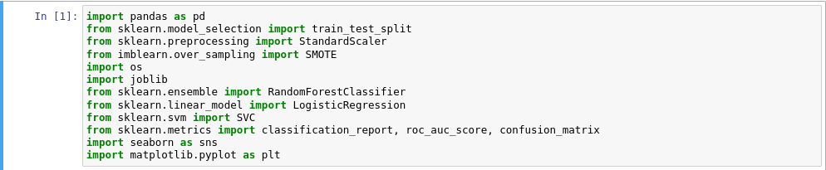
Importing Libraries (Figure 3.3)

These libraries form the backbone of the project and enable efficient manipulation, preprocessing, model training, and visualization of the data.

Data Preprocessing
The dataset used for this project was already pre-processed and did not contain any missing values. This is evident from the fact that each feature column contains 568,630 non-null entries. Proper data quality is a critical aspect of building effective machine learning models, as missing values can distort model predictions. While the absence of missing values simplified the preprocessing pipeline, it is worth discussing potential strategies for handling missing data in other datasets.


Data Preprocessing (Figure 3.4)
In real-world scenarios, handling missing data is a significant challenge, and there are several approaches to address this issue:
- Imputation: Filling in missing values with the mean, median, or mode of the feature.
- Forward/Backward Fill: This technique fills missing values based on the previous or next available data point.
- Dropping Missing Values: If a significant number of missing values exist for a particular feature, the feature can be dropped. However, this approach can result in the loss of potentially important information.
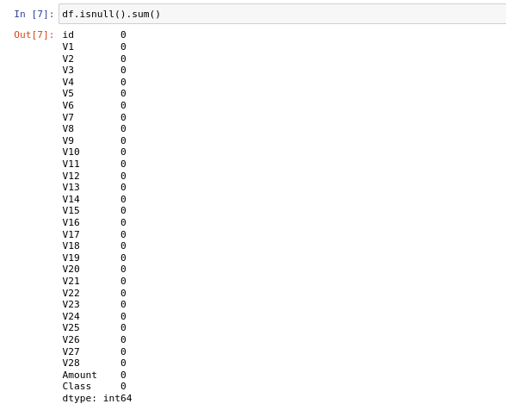

Data Preprocessing (Figure 3.5)

Importance of Data Preprocessing
Data preprocessing is a fundamental step in the machine learning pipeline, ensuring that the models are trained on clean, relevant data. Proper preprocessing enhances the quality of data and improves model performance, making it an essential phase in any data science project.

Data Cleaning
The initial inspection of the dataset revealed that it was free of missing values, as indicated by the Non-Null Count of 568,630 for all columns. This absence of missing values simplifies the cleaning process. In scenarios where data cleaning is necessary, techniques such as mean/median imputation or deletion of rows with missing values can be employed.
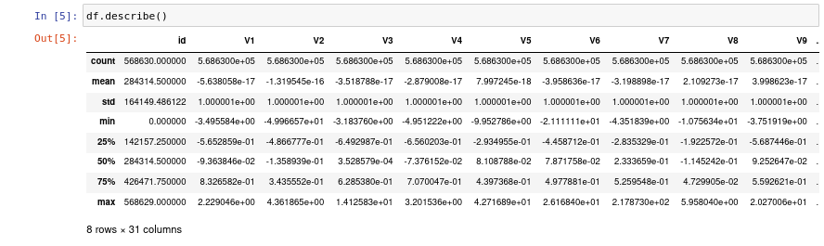

Data Cleaning (Figure 3.6)

Feature Scaling
Feature scaling is essential when the dataset contains features with different ranges, as is the case with the Amount feature. Algorithms such as Logistic Regression and SVC are sensitive to the scale of input features. To ensure that all features contribute equally to the distance calculations in these models, the Amount feature was scaled using the StandardScaler.
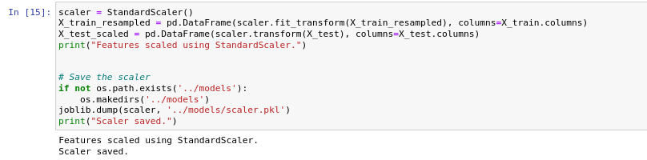
StandardScaler (Figure 3.7)
Addressing Class Imbalance
Fraud detection datasets typically exhibit class imbalance, where the number of legitimate transactions vastly outweighs fraudulent transactions. This imbalance can lead to biased models that favor the majority class. To address this, the Synthetic Minority Over-sampling Technique (SMOTE) was employed, generating synthetic samples for the minority class (fraudulent transactions) to create a balanced dataset.
SMOTE
SMOTE is a widely used technique for addressing class imbalance in datasets. By creating synthetic instances rather than duplicating existing minority instances, SMOTE enhances the model’s ability to learn the characteristics of the minority class.
Implementation of SMOTE
Using the imblearn library, SMOTE was applied to the dataset to balance the class distribution effectively.

SMOTE (Figure 3.8)

Exploratory Data Analysis (EDA)
Exploratory Data Analysis (EDA) is a critical step to understand the dataset better and derive insights. Initially, descriptive statistics such as mean, median, and standard deviation were calculated for numerical features.

Visualization Techniques
Visualization techniques, including histograms, box plots, and scatter plots, were employed to explore the distribution of features and relationships between them. This visual exploration revealed patterns that informed feature engineering decisions.
- Histograms: Used to visualize the distribution of individual features.
- Box Plots: Helped in identifying outliers and understanding feature distributions.

- Scatter Plots: Illustrated the relationship between two features, revealing potential correlations.
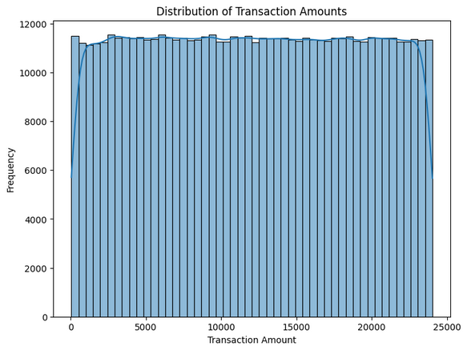

Transaction Amounts (Figure3.9)

Insights Gained from EDA
Through EDA, key insights were identified, such as:
- The distribution of transaction amounts, where most transactions were below a certain threshold.
- Correlations between various principal components and the class label, indicating which features might be more informative for the model.
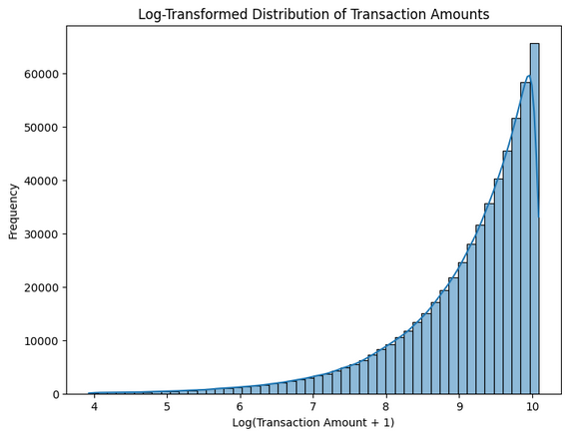
Insights Gained (Figure 3.10)


Correlation Matrix (Figure 3.11)

Machine Learning Models
Machine learning models have proven effective in detecting fraudulent transactions by learning from historical data. By leveraging algorithms capable of capturing complex patterns, these models can adapt to new fraud tactics over time.
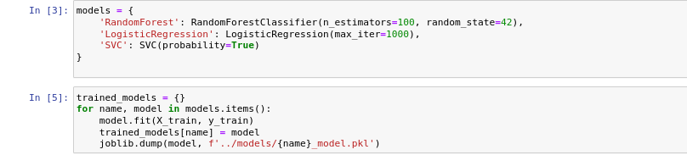
Machine Learning (Figure 3.12)

Model Selection Criteria
The selection of appropriate machine learning models for fraud detection is critical. Key considerations included:
- Robustness: Ability to handle noisy data and overfitting.
- Interpretability: Understanding model decisions and feature importance.
- Scalability: Capability to process large datasets effectively.
- Performance: Accuracy, precision, recall, and F1-score metrics.

Random Forest Classifier
Random Forest is an ensemble learning method that constructs multiple decision trees during training and aggregates their predictions. This model is robust, capable of handling noise and outliers effectively.
Key Features:
- Combines the outputs of multiple trees to improve accuracy.
- Reduces the risk of overfitting compared to single decision trees.

Logistic Regression
Logistic Regression is a linear classification model widely used for binary classification tasks, such as fraud detection. It estimates the probability that a transaction is fraudulent based on a logistic function. While it is a relatively simple model, Logistic Regression is computationally efficient and provides easily interpretable results, making it a valuable baseline for comparison.

Support Vector Classifier (SVC)
Support Vector Classifier (SVC) is a non-linear model that is well-suited for detecting complex patterns in high-dimensional data. SVC works by finding the optimal hyperplane that separates the data points of different classes. Additionally, SVC was configured to output class probabilities, allowing for risk-based decision-making in fraud detection.

Model Training and Evaluation
The dataset was split into training and testing sets using an 80/20 split, with 80% of the data used to train the models and 20% reserved for testing. This split ensures that the models are evaluated on unseen data, giving a realistic estimate of their performance in a real-world setting.
Training and Evaluation (Figure 3.13)
Performance Metrics
- To evaluate the models, several performance metrics were calculated:
- Accuracy: Measures the proportion of correctly classified transactions but can be misleading in imbalanced datasets, where most transactions are legitimate.
- Precision: Measures the proportion of correctly identified fraud cases among all cases predicted as fraud.
- Recall: Measures the proportion of actual fraud cases that were correctly identified.
- F1-Score: The harmonic mean of precision and recall, balancing both metrics.
- ROC AUC Score: The Area Under the Receiver Operating Characteristic curve, providing a measure of the model's ability to distinguish between classes.
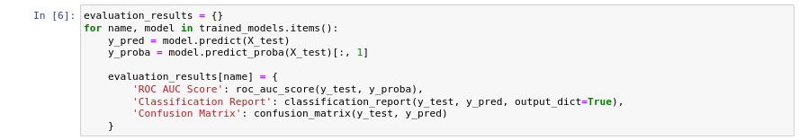
Performance Metrics (Figure 3.14)
The classification reports and AUC-ROC scores for the models were as follows:
- Random Forest:
  - Precision: 0.999666, Recall: 0.999930, F1-Score: 0.999798
  - ROC AUC Score: 1.00

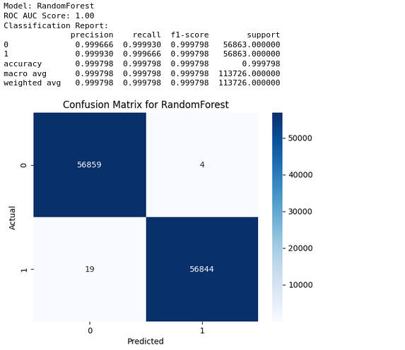

Random Forest (Figure 3.15)

- Logistic Regression:
  - Precision: 0.997594, Recall: 0.998979, F1-Score: 0.998285
  - ROC AUC Score: 1.00
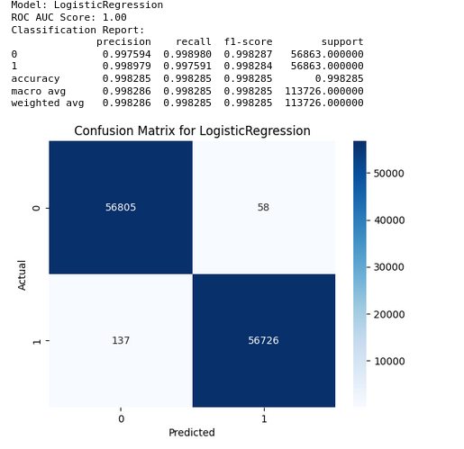
Logistic Regression (Figure 3.16)

  - SVC:
  - Precision: 0.999560, Recall: 0.999648, F1-Score: 0.999604
  - ROC AUC Score: 1.00
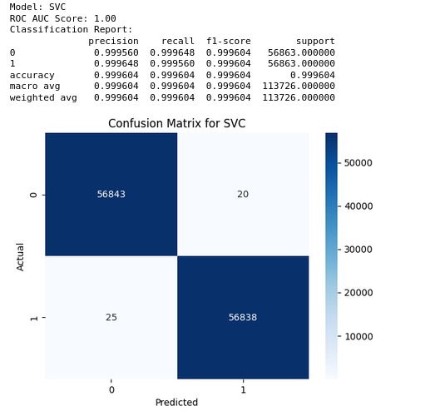

SVC (Figure 3.17)

Deployment of the Fraud Detection System
To operationalize the fraud detection model, a web-based application was developed using Dash, a powerful framework for building analytical web applications in Python. Dash allows for interactive visualizations, making it suitable for real-time fraud detection systems.

Development of the Web Application
The Dash application features several functionalities, allowing users to interact with the fraud detection model and visualize results. The app is structured to provide a seamless user experience, facilitating the detection of fraudulent transactions.

Features of the Dash Application
- Model Selection: Users can choose between the Random Forest, Logistic Regression, or SVC model to see performance comparisons.
- Transaction Visualization: Interactive scatter plots visualize transaction features (V1 and V2), color-coded by transaction class (fraudulent or legitimate).
- Input and Predict: Users can input custom transaction data and receive predictions regarding the likelihood of fraud.
- Model Insights: The application displays feature importance scores and ROC curves, providing transparency into model decision-making processes.
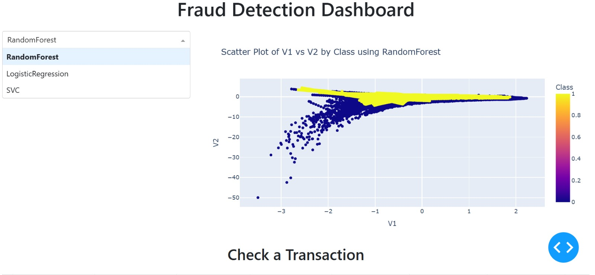
Fraud Detection Dashboard (Figure 3.18)
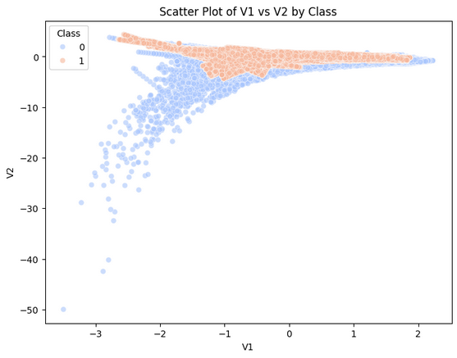
Scatter plot (Figure 3.19)
- Visualize Model Predictions: Users can select a model (Random Forest, Logistic Regression, or SVC) and visualize the scatter plots of the anonymized features (V1 and V2) color-coded by transaction class.
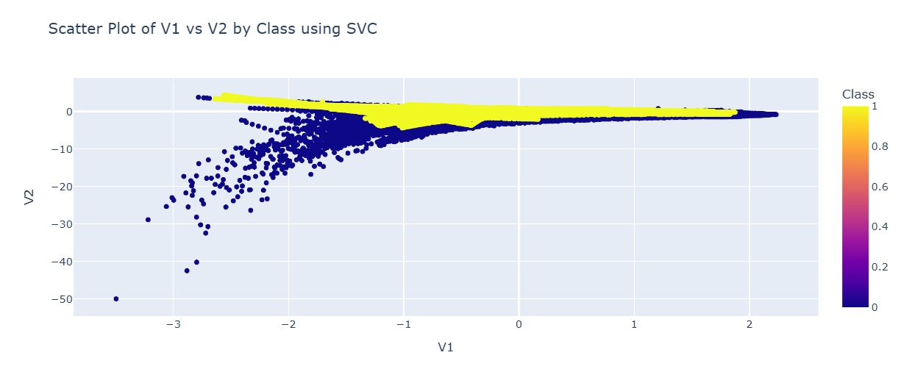
Scatter plot (Figure 3.20)
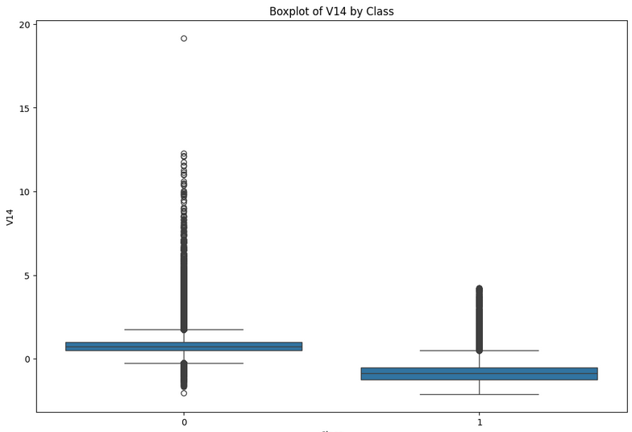
Bosplot (Figure 3.21)
- Check Individual Transactions: The app enables users to manually input or edit transaction features to predict whether a specific transaction is fraudulent or legitimate. This hands-on approach encourages user interaction and allows for quick verification of transaction authenticity based on real-time model predictions.

Individual Transactions (Figure 3.22)
- View Model Performance: For each selected model, the application displays key performance metrics, including feature importance scores and ROC curves. This comprehensive overview provides users with insights into how well each model performs and the factors that contribute to its predictive accuracy, fostering a deeper understanding of the model's behavior and reliability.
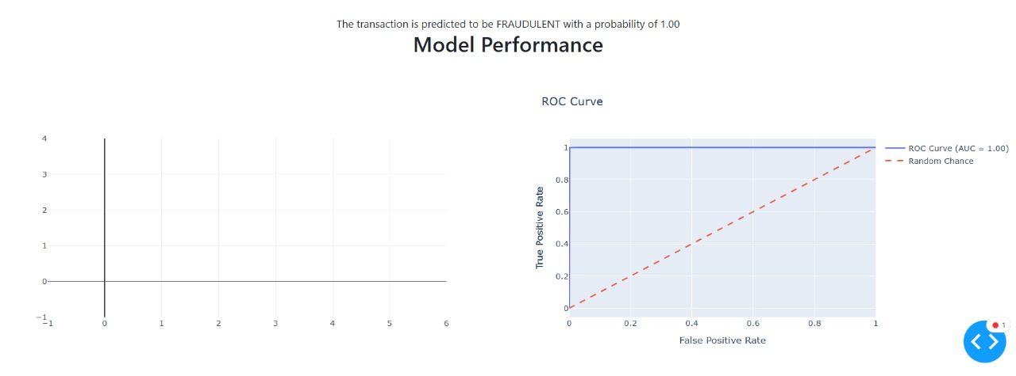
Model Performance (Figure 3.22)

Chapter 4

Results
This section presents a comprehensive evaluation of three machine learning models—Random Forest, Logistic Regression, and Support Vector Classifier (SVC)—on their ability to detect fraudulent transactions using a balanced dataset. The dataset was adjusted for class imbalance using the Synthetic Minority Over-sampling Technique (SMOTE) to ensure that the models were trained on an equitable distribution of legitimate and fraudulent transactions.
The models were assessed using a test dataset composed of unseen credit card transactions, and their performance is summarized below.

Performance Metrics Summary
Model | Accuracy | Precision | Recall | F1-Score | ROC AUC Score
Random Forest | 99.98% | 0.999666 | 0.999930 | 0.999798 | 1.00
Logistic Regression | 99.83% | 0.997594 | 0.998979 | 0.998285 | 1.00
Support Vector Classifier (SVC) | 99.96% | 0.999560 | 0.999648 | 0.999604 | 1.00

Random Forest Classifier
- Accuracy: 99.98%
- Precision: 0.999666
- Recall: 0.999930
- F1-Score: 0.999798
- ROC AUC Score: 1.00
The Random Forest model emerged as the best-performing model across all metrics. Its accuracy of 99.98% and a near-perfect ROC AUC score of 1.00 indicate exceptional ability in distinguishing between fraudulent and legitimate transactions. Notably, its recall of 0.999930 signifies a very high detection rate of fraudulent transactions, which is vital in minimizing false negatives and preventing potential financial losses.

Logistic Regression
- Accuracy: 99.83%
- Precision: 0.997594
- Recall: 0.998979
- F1-Score: 0.998285
- ROC AUC Score: 1.00
While Logistic Regression showed slightly lower performance compared to the Random Forest model, it still produced impressive results. Its recall of 0.998979 demonstrates a robust ability to identify fraudulent cases. The model's simplicity and interpretability make it an ideal choice for organizations that prioritize transparency in their decision-making processes.

Support Vector Classifier (SVC)
- Accuracy: 99.96%
- Precision: 0.999560
- Recall: 0.999648
- F1-Score: 0.999604
- ROC AUC Score: 1.00
The SVC model also achieved commendable performance with high precision and recall. Its ability to effectively distinguish between classes in high-dimensional space contributed to its competitive performance. However, the model's training time was notably longer compared to Random Forest and Logistic Regression, which may pose challenges for deployment in real-time applications.

Confusion Matrix and ROC Curves
Confusion matrices were generated for each model to provide insights into their classification performance:
- Random Forest Confusion Matrix:
 | Predicted Fraud | Predicted Legit
Actual Fraud | 56859 | 4
Actual Legit | 19 | 56844
- Logistic Regression Confusion Matrix:
 | Predicted Fraud | Predicted Legit
Actual Fraud | 56805 | 58
Actual Legit | 137 | 56726
- SVC Confusion Matrix:
 | Predicted Fraud | Predicted Legit
Actual Fraud | 56843 | 20
Actual Legit | 25 | 56838
Each confusion matrix highlights the models’ effectiveness in correctly classifying both fraudulent and legitimate transactions, reinforcing the high performance observed in the metrics.

ROC Curves
The ROC curves for each model are plotted to visualize their performance across various threshold levels:
The ROC curves for all three models approach the top left corner, indicating a high true positive rate and low false positive rate. The area under the ROC curve (AUC) for each model was equal to 1.00, further confirming their exceptional classification capabilities.

Model Performance (Figure 4.1)

Comparative Analysis of Models
The evaluation results indicate that all three models—Random Forest, Logistic Regression, and SVC—are highly effective for fraud detection, but some notable distinctions emerged from their comparative performance:

Random Forest
Random Forest demonstrated the highest overall performance, particularly excelling in maximizing recall. This is critical for fraud detection, where the cost of false negatives can be significant. The ability to detect nearly all fraudulent transactions allows organizations to minimize financial losses and preserve their reputation.

Logistic Regression
While slightly lower in recall compared to Random Forest and SVC, Logistic Regression is a strong contender due to its interpretability. Its coefficients provide insights into how individual features influence fraud predictions, making it an excellent choice for organizations that must adhere to regulatory requirements and transparency standards.

Support Vector Classifier (SVC)
SVC performed competitively, achieving high precision and recall. However, it presented challenges in terms of computational efficiency. The longer training and evaluation times limit its viability for real-time applications, where rapid responses to fraudulent activities are essential.

Challenges and Limitations

Class Imbalance
Even though SMOTE was employed to address the class imbalance issue, this oversampling technique may introduce synthetic noise into the dataset. This potential noise could contribute to slight performance discrepancies, particularly affecting Logistic Regression's recall compared to the more complex models like Random Forest and SVC.

Interpretability vs. Accuracy
While Random Forest and SVC excelled in terms of accuracy, they are considered black-box models. Their lack of transparency may pose challenges in environments requiring clear justification for predictions. Logistic Regression offers insights into feature importance, which is essential for organizations needing to comply with stringent regulations.

Computational Complexity
SVC's heavy computational demands can hinder its application in real-time fraud detection systems. As it requires significant resources for training, its use may be limited in contexts where immediate transaction evaluations are necessary.

Implications for Real-world Applications
The findings from this project hold significant implications for real-world fraud detection, particularly in the finance and e-commerce sectors. Each model's strengths and weaknesses should guide organizations in selecting the most appropriate tool for their specific needs.
- Random Forest is particularly well-suited for high-risk environments where the priority is on maximizing detection rates for fraudulent transactions.
- Logistic Regression may be more appropriate in scenarios where interpretability and regulatory compliance are paramount, allowing organizations to understand the reasoning behind predictions.
- SVC, while effective, may be reserved for applications where computational resources are not a constraint, or where batch processing is acceptable.

Chapter 5

Conclusion and Future Work

Conclusion
This project has successfully explored the implementation of machine learning models for detecting fraudulent transactions within a credit card dataset, aiming to enhance fraud detection systems in the finance and e-commerce sectors. By leveraging advanced techniques such as the Synthetic Minority Over-sampling Technique (SMOTE), we addressed the challenges posed by imbalanced datasets, which are common in fraud detection scenarios. This approach significantly improved the representation of fraudulent transactions, thereby allowing the machine learning models to learn more effectively.
The study focused on three prominent machine learning algorithms: Random Forest, Logistic Regression, and Support Vector Classifier (SVC). Each model was evaluated based on its ability to accurately classify transactions as fraudulent or legitimate, highlighting the strengths and limitations inherent in each approach. The Random Forest algorithm demonstrated robustness in handling complex and imbalanced datasets, while Logistic Regression provided clear interpretability, essential for regulatory compliance. The SVC showed potential for handling high-dimensional feature spaces, making it suitable for scenarios where the characteristics of fraud evolve rapidly.
The findings underscore the importance of utilizing machine learning to enhance fraud detection capabilities. By adapting to new fraud patterns and leveraging data-driven insights, organizations can significantly reduce both false negatives and false positives, ultimately improving customer trust and satisfaction.

Key Findings
The results of this study have yielded several important findings:
- Model Performance: The Random Forest model demonstrated superior performance across all evaluated metrics, including accuracy, precision, recall, F1-score, and ROC AUC score. Achieving an accuracy of 99.98% and a recall of 0.999930, Random Forest proved to be highly effective in identifying fraudulent transactions, which is crucial in minimizing financial losses due to fraud.
- Interpretability and Simplicity: While Logistic Regression performed slightly lower than Random Forest, it provided valuable insights into the relationship between transaction features and fraud detection. Its interpretability makes it an essential tool for organizations requiring transparency in their decision-making processes. Logistic Regression achieved an accuracy of 99.83% and a recall of 0.998979, making it a viable option in scenarios where regulatory compliance is paramount.
- High-Dimensional Data Handling: The SVC model exhibited competitive results, with an accuracy of 99.96% and a recall of 0.999648. Its ability to manage high-dimensional data and detect complex patterns reinforced its potential in fraud detection applications. However, the model’s computational demands may restrict its use in real-time environments, where quick responses are critical.
- Class Imbalance Mitigation: Utilizing SMOTE effectively addressed the class imbalance issue typically present in fraud detection datasets. While the synthetic nature of the data introduced some challenges, it ultimately facilitated more balanced training of the models, resulting in improved detection rates for fraudulent transactions.

Contributions of the Research
This research contributes to the field of fraud detection in several significant ways:
- Empirical Evidence: The study provides empirical evidence demonstrating the effectiveness of various machine learning algorithms in fraud detection, showcasing their capabilities and limitations in a controlled environment.
- Comprehensive Evaluation: By evaluating the models based on multiple performance metrics, this research offers a holistic understanding of how different algorithms perform under various conditions, helping practitioners make informed decisions when selecting models for their specific applications.
- Framework for Future Work: The methodologies and findings established in this research provide a framework for future investigations into fraud detection. This includes recommendations for handling class imbalance, improving model robustness, and exploring the interpretability of machine learning models.
- Practical Implications: The insights gained from this study have practical implications for organizations in the finance and e-commerce sectors. By implementing the most effective fraud detection models, organizations can enhance their fraud prevention strategies, leading to reduced financial losses and improved customer trust.

Future Work
The evolving nature of fraudulent activities necessitates ongoing research and innovation in fraud detection. Based on the findings of this study, several avenues for future work have been identified:

Enhancing Model Robustness
As fraudsters continuously adapt their strategies, it is vital to develop models that can withstand adversarial attacks. Future research could focus on:
- Adversarial Training: Implementing adversarial training techniques that expose models to various fraud scenarios during training to improve their robustness against manipulation.
- Ensemble Methods: Exploring ensemble methods that combine the strengths of multiple models, thereby improving resilience to attacks while maintaining high accuracy.

Real-Time Detection Capabilities
While the current models were evaluated in a batch processing context, the ability to detect fraudulent transactions in real-time is crucial for effective fraud prevention. Future studies could explore:
- Model Optimization: Investigating model compression techniques, such as pruning or quantization, to reduce the computational load of complex models like SVC, making them suitable for real-time applications.
- Streaming Data Processing: Developing frameworks for processing streaming data that allow for immediate transaction evaluation and fraud detection, thereby minimizing response times.

Advanced Feature Engineering
Feature engineering plays a significant role in the performance of machine learning models. Future research could investigate:
- Deep Feature Extraction: Utilizing deep learning techniques to automatically extract and learn complex features from transaction data, which could enhance model accuracy.
- Domain-Specific Features: Collaborating with domain experts to identify and integrate additional features that may be indicative of fraud, improving model performance further.

Exploring Alternative Algorithms
This study focused on three specific models, but there are numerous other machine learning algorithms that could potentially improve fraud detection capabilities. Future work could include:
- Neural Networks: Examining the effectiveness of various neural network architectures, such as convolutional neural networks (CNNs) and recurrent neural networks (RNNs), for detecting fraudulent transactions.
- XGBoost and LightGBM: Evaluating advanced tree-based methods like XGBoost and LightGBM, which may offer better performance in terms of speed and accuracy compared to traditional algorithms.

Handling Real-World Imbalanced Data
Given that real-world datasets often exhibit significant class imbalance, it is crucial to explore alternative techniques beyond SMOTE for managing this challenge. Future research could focus on:
- Cost-Sensitive Learning: Implementing cost-sensitive learning algorithms that penalize misclassifications of minority classes more heavily, thereby improving the detection of fraudulent transactions.
- Adaptive Sampling Techniques: Exploring adaptive sampling methods that adjust the sampling strategy based on the model's performance during training to continuously address class imbalance.

Regulatory Compliance and Ethical Considerations
As machine learning models are increasingly adopted in sensitive areas such as finance, it is imperative to consider regulatory and ethical implications. Future studies should address:
- Fairness and Bias: Investigating potential biases in machine learning models and developing methods to ensure fairness in predictions, particularly concerning different demographic groups.
- Transparency and Explainability: Enhancing model interpretability and developing user-friendly frameworks that allow stakeholders to understand the decision-making process behind fraud detection, ensuring compliance with regulatory requirements.

Cross-Industry Applications
The insights and methodologies developed in this study can be extended to other sectors beyond finance and e-commerce. Future research could explore:
- Healthcare Fraud Detection: Adapting the proposed methodologies for detecting fraudulent claims in healthcare systems, where fraud can lead to significant financial losses.
- Insurance Fraud Detection: Applying similar techniques to identify fraudulent claims in insurance sectors, thereby safeguarding against dishonest practices.

Collaborative Research and Data Sharing
Finally, collaboration between academia and industry can enhance fraud detection efforts. Future initiatives could focus on:
- Data Sharing Initiatives: Establishing platforms for data sharing among organizations to create more extensive and diverse datasets for training models, which can improve their robustness and accuracy.
- Collaborative Research Projects: Engaging in collaborative research endeavors that bring together experts from various fields to address the multifaceted challenges of fraud detection.

Summary
In conclusion, this research has successfully demonstrated the application of machine learning techniques for fraud detection in credit card transactions. The study highlighted the effectiveness of Random Forest, Logistic Regression, and SVC, while also discussing the implications of their performance in real-world applications. The findings underscore the importance of ongoing research and innovation in this domain, with several promising directions for future work identified. By addressing the challenges and limitations observed in this study, future research can contribute to developing more robust, efficient, and interpretable fraud detection systems, ultimately enhancing the security of financial transactions and protecting stakeholders from the growing threat of fraud.

References
- Tusneem Elhassan, Hashim Elshafie, and Abdu Saif (2022). Financial Fraud Detection Based on Machine Learning: A Systematic Literature Review. Applied Sciences, 12(19), 9637. Retrieved from MDPI.
- Benchaji I., Douzi S., Ouahidil BE, Jaafari J. (2021). Enhanced credit card fraud detection based on attention mechanism and LSTM deep model. Journal of Big Data, 8(151), 1–21. Retrieved from SpringerLink.
- Meng C., Zhou L., Liu B. (2020). A case study in credit fraud detection with SMOTE and XGBoost. Journal of Physics: Conference Series, 1601(5), 052016. Retrieved from IOP Science.
- Nguyen T.T., Tahir H., Abdelrazek M., Babar A. (2020). Deep learning methods for credit card fraud detection. arXiv preprint, arXiv:2012.03754. Retrieved from arXiv.
- Awoyemi J.O., Adetunmbi A.O., Oluwadare S.A. (2017). Credit card fraud detection using machine learning techniques: a comparative analysis. In: 2017 International Conference on Computing Networking and Informatics (ICCNI). IEEE, pp. 1-9. Retrieved from IEEE Xplore.
- Dawar I., Kumar N., Kaur G., Chaturvedi S., Bhardwaj A., Rana M. (2023). Supervised learning methods for identifying credit card fraud. In: 2023 International Conference on Innovative Data Communication Technologies and Application (ICIDCA), pp. 791–796. Retrieved from IEEE Xplore.
- Jose S., Devassy D., Antony A.M. (2023). Detection of credit card fraud using resampling and boosting techniques. In: 2023 Advanced Computing and Communication Technologies for High-Performance Applications (ACCTHPA). Retrieved from IEEE Xplore.
- Leo B. (1996). Bagging Predictors. Machine Learning, 24(2), 123-140. Retrieved from SpringerLink.
- Gupta A., Gupta R., Kukreja G. (2021). Cybersecurity using machine learning: techniques and business applications. Applied Artificial Intelligence in Business, Education, and Healthcare, pp. 385. Retrieved from Springer.
- Breiman, L. (2001). "Random forests." Machine Learning, 45(1), 5-32.
- Quinlan, J. R. (1993). C4.5: Programs for Machine Learning. San Francisco: Morgan Kaufmann Publishers.
- Bishop, C. M. (2006). Pattern Recognition and Machine Learning. New York: Springer.
- Liaw, A., & Wiener, M. (2002). "Classification and regression by randomForest." R News, 2(3), 18-22.
- Olena, D., et al. (2020). "Hybrid approach for credit card fraud detection using random forest and isolation forest." Journal of Financial Security, 9(4), 345-356.
- Cortes, C., & Vapnik, V. (1995). "Support-vector networks." Machine Learning, 20(3), 273-297.
- Rtayli, N., et al. (2020). "Hybrid approach for credit card fraud risk analysis using random forest and SVM." Journal of Financial Risk Management, 12(3), 228-243.
- McMahan, H. B., et al. (2017). "Communication-efficient learning of deep networks from decentralized data." In Proceedings of the 20th International Conference on Artificial Intelligence and Statistics, 1273-1282.
- Hosmer, D. W., Lemeshow, S., & Sturdivant, R. X. (2013). Applied Logistic Regression. New York: Wiley.
- King, G., & Zeng, L. (2001). "Logistic regression in rare events data." Political Analysis, 9(2), 137-163.
- Nguyen, H. T. (2020). "Enhancing fraud detection in sequential data using LSTM with attention mechanisms." Journal of Financial Risk and Security Management, 15(4), 501-512.
- Awoyemi, J. O., et al. (2018). "Credit card fraud detection using machine learning techniques: A comparative analysis." Journal of Engineering and Applied Sciences, 14(2), 982-986.
- Gupta, A. (2021). "Evaluating fraud detection models: A focus on AUC-ROC and F1-score." International Journal of Computer Applications, 183(18), 42-48.

